**Supplementary Materials**

The following are supplementary tables and figures accompanying Freedman and Dingle (2018).

**Table S1**: This table provides a summary of the setup for the experiment that investigated wing morphological characteristics in relation to larval host plant. The data presented here are part of a larger experiment that involves rearing six monarch populations on seven species of milkweed host plant to investigate patterns of local adaptation across the monarch’s global range (Freedman et al., in prep).

**Table S2**: This table provides a summary of which factors associated with variation in monarch wing morphology are consistent with selection effects versus phenotypic plasticity.

**Figure S1**: This first figure panel shows when, during the calendar year, monarch specimens were collected. This is intended to show that monarch collections occurred over the whole year, though the majority of specimens were collected during late summer in the core of the monarch’s eastern breeding range. The peak in abundance around Julian date 80 corresponds to the California overwintering specimens included in Yang et al. (2016). The second figure panel shows how the daylength index, which was included as a linear model term, was calculated across the calendar year. The highest value (1.0) for the daylength index occurs during the summer solstice, while the lowest value (-1.0) occurs during the winter solstice. Points along the curve correspond to individual collected monarchs. This model term was included to account for the possibility that photoperiod might influence adult wing morphology.

**Figure S2**: This figure shows the correlations between all of the measurements taken from individual monarchs (see Figure 1). Because of the strong correlation between all size-related variables, we used only wing area as our response variable in models reported in the text. Figure generated using the chart.Correlation function in the PerformanceAnalytics package [58].

**Figure S3**: This figure shows the relationship between body mass and wing area for all butterflies collected during the host plant rearing experiment (see Table S1). The rationale for including this figure is that is shows that there is indeed a strong correlation between wing area and overall body mass. Since museum specimens cannot be used for determining wing loading (the ratio between wing area and body mass), this is important because it demonstrates that wing loading does not change appreciably with increasing wing area. Furthermore, this relationship does not seem to vary strongly based on larval host plant identity.

**References included in supplementary materials that do not appear in main text**

1. Altizer S.M., Oberhauser K.S., Effects of the protozoan parasite ophryocystis elektroscirrha on the fitness of monarch butterflies (Danaus plexippus), J. Invertebr. Pathol., 1999, 74, 76–88
2. Bradley C.A., Altizer S., Parasites hinder monarch butterfly flight: implications for disease spread in migratory hosts, Ecol. Lett., 2005, 8, 290–300.
3. Peterson, B.G. Carl, A. PerformanceAnalytics: Econometric tools for performance and risk analysis. R package version 1.4.3541, 2014, https://CRAN.R-project.org/package=PerformanceAnalytics

|  |  |  |  |  |  |
| --- | --- | --- | --- | --- | --- |
| **Monarch Population** | **Maternal Families** | **Larval Host Species** | | | |
| ***Asclepias syriaca*** | ***Asclepias fascicularis*** | ***Asclepias curassavica*** | ***Gomphocarpus spp.*** |
| **Eastern North America (IA, MI)** | 7 | 10 | 8 | 12 | 23 |
| **Western North America (CA)** | 10 | 12 | 11 | 13 | 24 |
| **Hawaii (Maui)** | 7 | 7 | 6 | 13 | 25 |
| **Australia (QLD)** | 1 | 8 | 7 | 7 | 27 |
| **Cumulative** | **25** | **37** | **32** | **45** | **99** |

**Table S1 –** Summary of host plant experiment. Monarch population refers to the source of collection for each population of monarchs tested. Maternal families refers to the number of maternal families tested for each monarch population. Numbers below each milkweed species correspond to the number of butterflies measured from each monarch population on each host plant. For *Gomphocarpus spp.*, we combine data from *Gomphocarpus* sourced from Australia and Hawaii, which likely represents a mix of *G. physocarpus* and *G. fruticosus*.

|  |  |
| --- | --- |
| **Wing size effects consistent with selection** | **Evidence for Effect** |
| **Migratory filtering –** Long-distance migration acts as a selective episode that favors individuals with larger wings | * Migratory butterflies have larger wings than non-migratory butterflies [8-11]. * Stable isotope data show a correlation between migration distance and forewing size [16,17]. * Overwintering monarchs are larger than summer-breeding monarchs; Mexican overwintering monarchs larger than California overwintering monarchs (Fig. 3). * Butterflies from higher latitudes have larger wings (Fig. 4), possibly due to selection acting during spring re-migration. |
| **Sexual selection –** Larger males may mate more and sire more offspring, either due to overcoming female resistance, female choice, or sperm competition | * Larger males mated more than smaller males in a cage experiment [26]. * Sperm from larger males may have a fertilization advantage in multiply-mated females [27]. |
| **Wing size effects consistent with phenotypic plasticity** | **Evidence for Effect** |
| **Host plant effects –** Butterflies may attain different sizes depending on larval host plant (identity, quantity, quality) | * Adult forewing size varies as a function of larval host plant species (Fig. 6). Common milkweed (*A. syriaca*), which is the predominant host for monarchs that reach Mexican overwintering sites, produces large adult butterflies [18]. * Food limitation may cause premature pupation and lead to small adults [50]. |
| **Temperature effects –** Butterflies that develop at lower temperatures are expected to have larger body size | * Limited evidence in monarchs (though see ref 30), but many other Lepidopterans show negative correlations between larval development temperature and adult body size. |
| **Photoperiod effects –** Decreasing photoperiod leads to reproductive diapause and other migration-associated phenotypes | * Monarchs reared under decreasing photoperiod have larger wings and higher body mass than monarchs reared under constant photoperiod [19]. |
| **Parasite effects** – Infection by the protozoan parasite *Ophryocystis elektroschirrha* (OE)reduces adult size | * Adult monarchs infected by OE have smaller wingspans [56] (but also see ref. 57) |

**Table S2 –** Summary of sources of monarch wing morphological variation.

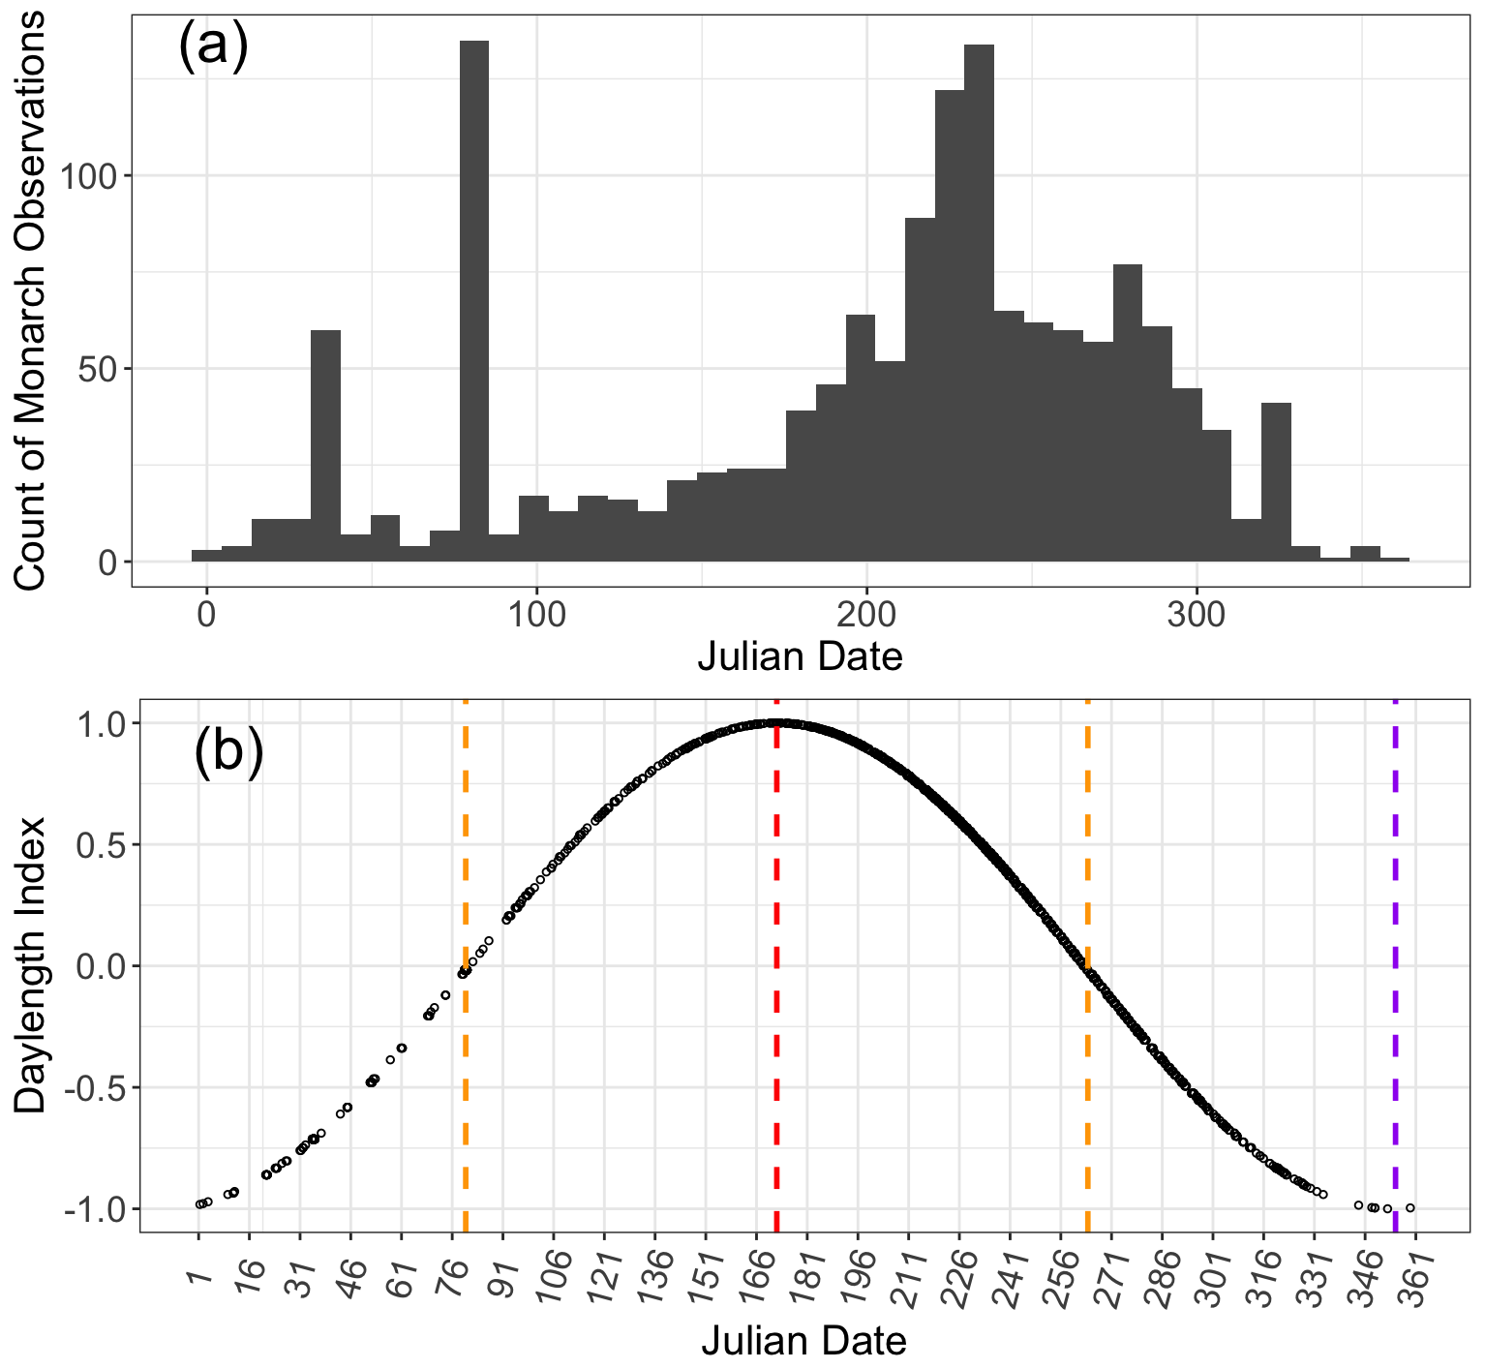

**Figure S1 – (a).** Histogram showing when monarchs included in this dataset were collected, compressed into a single calendar year. **(b).** Depiction of how the daylength index at time of collection was calculated. Orange vertical lines correspond to the spring and fall equinoxes, while red and purple lines correspond to the summer and winter solstices, respectively. Each point represents a single collected monarch.

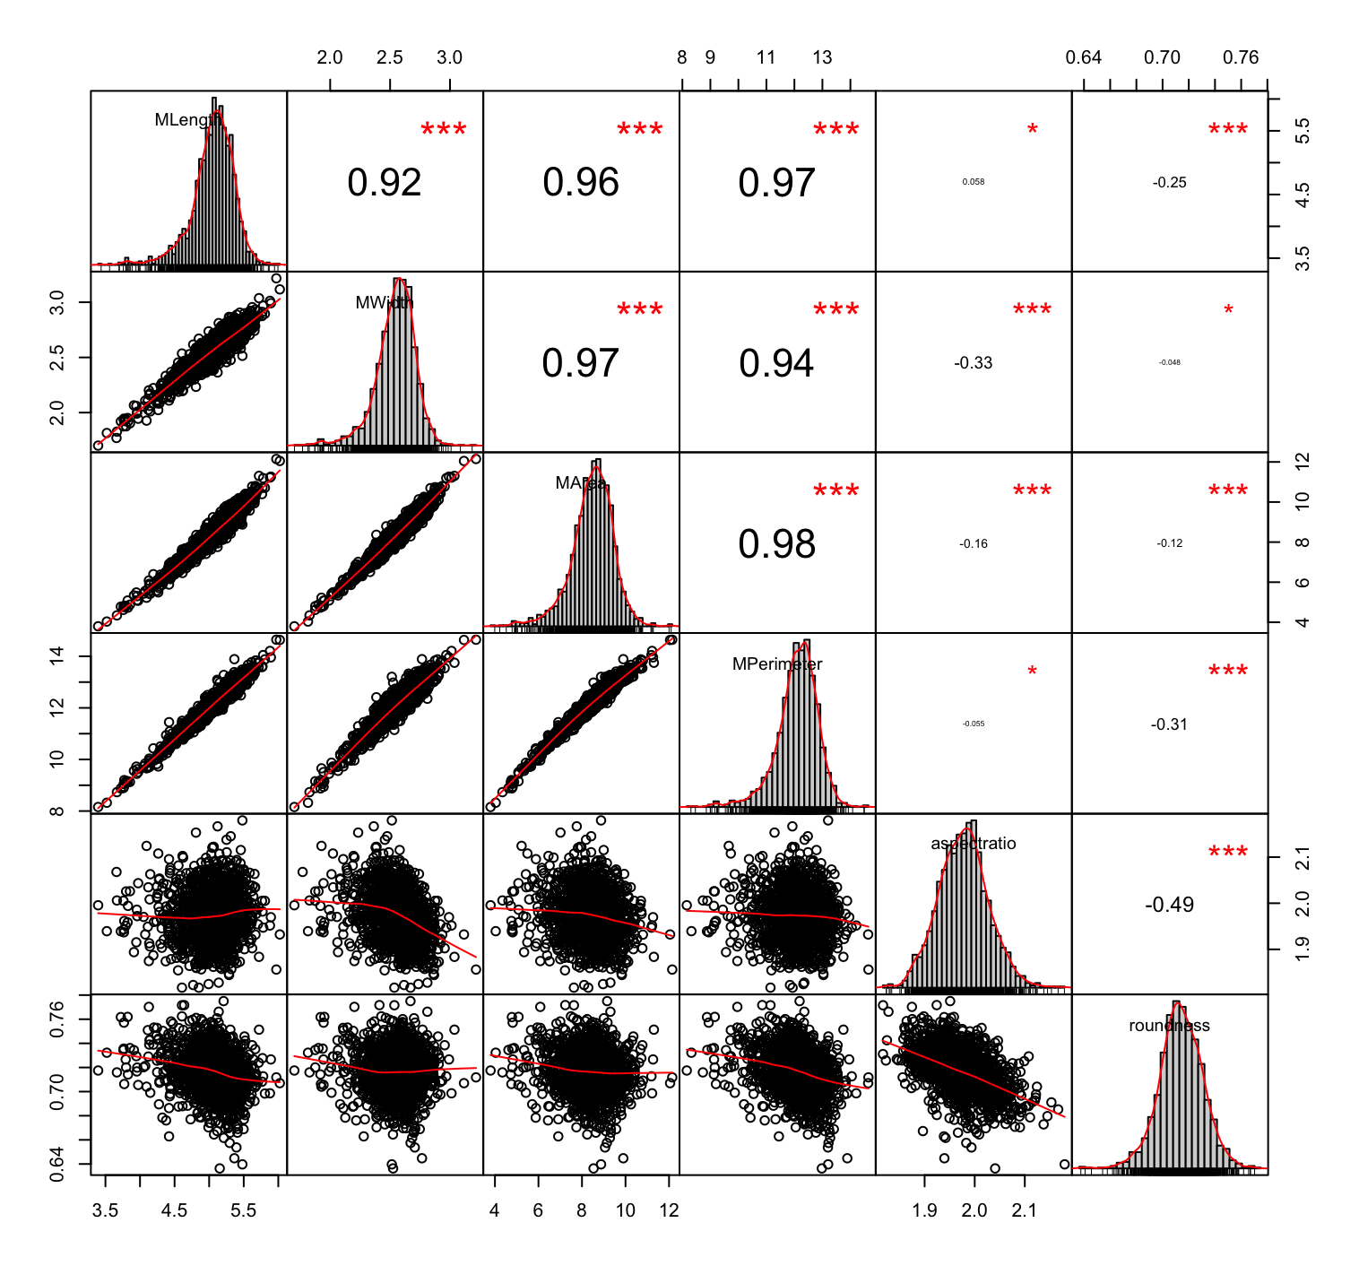

**Figure S2 –** Correlations between all measured wing values. The diagonal of the matrix shows the distribution of values for each forewing measurement (mean of left and right forewings), in order from top left: length, width, area, perimeter, aspect ratio, roundness. Off-diagonal elements in the upper right show the R2 value for a simple linear regression between all pairwise combinations of measurements. When forewing area is included as a predictor in a model with wing roundness as the response variable, forewing area is indeed a significant predictor and reapportions variance previously associated with sex.

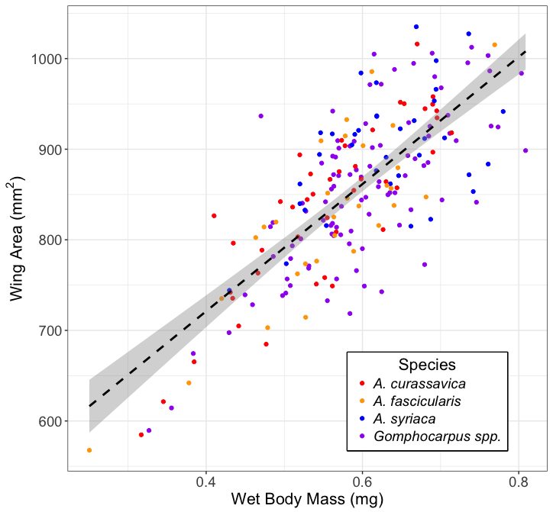

**Figure S3** – Wing area and body mass were highly correlated (R2 = 0.57, p <0.001) for butterflies reared on various host plant species, suggesting that wing area may be an appropriate proxy for wing loading.